PREAMBLE

The flowing pages represent a draft flight manual that has been prepared to help owners of new gyroplanes enter data required for the issue of the final ASRA approved flight manual. You should have Microsoft Word and Excel loaded on your PC.

If you do not have a PC, or do not have the necessary PC skills, contact the Operations Manager or Technical Manager who can have the flight manual created for you.

Owners are free to edit the following pages with the data that is relevant to their particular gyroplane. Headings/fields in RED – are mandatory where applicable.

Table of Contents

This will be updated once the Flight Manual has been created.

Section 1- Specifications

These are the general details of the gyroplane and are required for identification. If you have 2 options available e.g. 2 sets of rotors, both manufacturers must be listed.

Section 2 – Limitations

This establishes the envelope the gyroplane must be operated within and represents the majority of the mandatory requirements. Clearly some fields are not required for single seat gyroplanes and can be deleted. Text with “?” will require your own parameter to be entered.

Follow the instructions on 2.09 to create the graph.

Section 3 – Normal Procedures

These procedures are samples only and can be fully edited with your particulars.

Section 4 – Emergency Procedures

These procedures are samples only and can be fully edited with your particulars except 4.07 (mandatory) which is required to be filled in.

Section 5 – Normal Procedures (Mandatory)

These schedules are samples only and can be fully edited with your particulars.

Section 6 – Maintenance Schedule (Mandatory)

These schedules are samples only and can be fully edited with your particulars

Once the flight manual is filled in with all your relevant details, delete this first page, change all the text back to black, save the file to your PC and submit to the ASRA registrar for final approval. Once approved the Flight Manual will appear on the Gyroplane file and can be downloaded at any time.

GYROPLANE FLIGHT MANUAL

GXXXX

Table of Contents
SECTION 1 4
SPECIFICATIONS 4
1.01 - GENERAL 4
1.02 - DIMENSIONS 4
1.04 - REDUCTION UNIT 4
1.05 - PROPELLER 4
1.06 - ROTOR 5
1.07 - ROTOR HEAD 5
1.08 - FUEL SYSTEM 5
SECTION 2 6
LIMITATIONS 6
2.01 - WEIGHT and BALANCE 6
2.02 - PERFORMANCE 6
2.03 - SPEEDS 6
2.04 - ROTOR 7
2.05 - ENGINE 7
2.06 - WIND 7
2.07 - MANOEUVRES 7
2.08 - TYPES OF OPERATION 7
2.09 – HEIGHT SPEED GRAPH (MTOW) 8
SECTION 3 9
NORMAL PROCEDURES 9
3.01 - PRE – FLIGHT INSPECTION 9
3.02 – BEFORE START 10
3.03 – ENGINE START 10
3.04 – AFTER START 11
3.05 - TAXIING 11
3.06 – BEFORE TAKE-OFF 11
3.07 – AFTER TAKE-OFF 11
3.08 – BEFORE LANDING 11
3.09 – AFTER LANDING 11
3.10 - SHUTDOWN 11
SECTION 4 12
EMERGENCY PROCEDURES 12
4.01 – ENGINE FIRE DURING START 12
4.02 – ENGINE FAILURE 12
4.03 – ENGINE FIRE IN FLIGHT 12
4.04 – ELECTRICAL FIRE INFLIGHT 12
4.05 – ELECTRICAL MALFUNCTIONS 13
4.06 – DITCHING 13
4.07 – LANDING WITH THE ENGINE AT IDLE OR STOPPED??? 13
SECTION 5 14
PERFORMANCE CHART 14
SECTION 6 15
MAINTENANCE SCHEDULE 15
6.01 – 25 Hourly Inspection 15
6.02 – 50 Hourly Inspection 15
6.03 – 100 Hourly Inspection 16
6.04 – 200 Hourly Inspection 16
6.05 – 500 Hourly Inspection 16

Insert Gyroplane photo here if required

SECTION 1

SPECIFICATIONS

1.01 - GENERAL

Gyroplane Type | Tandem/Side by Side/Single Seat ?
ASRA Listing No | G……
ASRA Approval No | If applicable?
Model | ?
Airframe Serial Number | ?

1.02 - DIMENSIONS

Length | ? m
Height | ? m
Width | ? m

1.03 - ENGINE

Manufacturer | ?
Type | ?
Displacement | ? cc
Horsepower | ?
Cycles | ?
Fuel Consumption @ ? rpm | ? L/Hr
Approved Oil Grade | ?
Serial No | ?

1.04 - REDUCTION UNIT

Manufacturer | ?
Type | Gear/Belt?
Ratio | ? : 1
Approved Oil Grade | ?
Serial No | ?

1.05 - PROPELLER

Manufacturer | ?
Diameter | ? in
Pitch | ? deg
Serial No | ?

1.06 - ROTOR

Manufacturer | ?
Rotor Diameter | ? ft
Rotor Chord | ? in
Materials | ?
Serial No | ?

1.07 - ROTOR HEAD

Manufacturer | ?
Material | ?
Prerotator | ?
Rotor Tachometer | ?
Serial No | ?

1.08 - FUEL SYSTEM

Capacity | ? ltrs
Unusable | ? ltrs
Approved Fuel Grade | ?
Delivery System | Fuel Injection/Carburettor?
Fuel Quantity Indicating System | Sight/Digital/Analogue Gauge?
Filter Type | Paper (*no 2 strokes)/inline mesh?
Water Drain | Yes

SECTION 2

LIMITATIONS

COMPLIANCE WITH THE FOLLOWING IS MANDATORY

2.01 - WEIGHT and BALANCE

Empty Weight (Includes oil, coolant and unusable fuel) | ? kg
Maximum allowable Take-off Weight | ? kg
Minimum Pilot Weight Solo Operations | ? kg
Maximum Passenger Weight | ? kg
Under seat Storage compartments | ? kg
Hang Test at empty weight (nose up/dn?) | ? deg
Hang Test at full weight (nose up/dn?) | ? deg

2.02 - PERFORMANCE

Take-off Distance to 50 feet (ISA, nil wind) No Prerotator | ? m
Take-off Distance to 50 feet (ISA, nil wind) with Prerotator | ? m
Sea Level Rate of Climb at “?” KIAS | ? ft/min
Minimum Sink Rate at “?” KIAS | ? ft/min
Best Glide Ratio at “?” KIAS | X.X:1
Landing Distance from 50 feet at “?” KIAS (ISA, nil wind) | ? m
Max operating altitude | ? ft

2.03 - SPEEDS

VNE (Never exceed airspeed) | ? KIAS
VMIN (Minimum airspeed straight and level flight) | ? KIAS
Normal take-off speed | ? KIAS
Short field take-off speed | ? KIAS
Normal cruise speed | ? KIAS
Normal climb speed | ? KIAS
VY (Best rate of climb speed) | ? KIAS
VX (Best angle of climb)  Normal approach speed | ? KIAS  ? KIAS
Short field approach speed | ? KIAS
Max. Taxiing Speed over rough ground | ? Kts
Max. Ground Speed on take-off | ? Kts
Max. Ground Speed on landing | ? Kts

2.04 - ROTOR

Maximum rotor RPM | ? rpm
Minimum rotor RPM in flight | ? rpm
Minimum sustained load factor | ? G
Minimum rotor RPM taxying | ? rpm
Pre-rotator operation is limited to | ?
Rotor brake must only be applied when less than  rotor speed is less than | ? rpm

2.05 - ENGINE

Maximum Engine RPM | ? rpm
Normal Engine Idle RPM | ? rpm
Minimum Oil Pressure | ? PSI
Maximum Oil Pressure | ? PSI
Minimum Water Temperature for Take-off | ? deg C
Maximum Water Temperature | ? deg C
Maximum Voltmeter Reading | ? volts

2.06 - WIND

Maximum Wind Normal Operations | ? Kts
Maximum crosswind | ? Kts
Maximum Tailwind | ? Kts

2.07 - MANOEUVRES

Aerobatic manoeuvres are prohibited.
Steep turns in excess of 60 degrees of bank are prohibited
Flight Load Factor Limits:
Positive G’s………… “?”
Negative G’s……….. Absolutely None
Avoid abrupt manoeuvres in the pitching plane.

2.08 - TYPES OF OPERATION

This aircraft is limited to flight by day in VMC.
Solo operations must be conducted from the “?” seat only.
For operations into registered/certified aerodromes, flashing beacons must be operating.

2.09 – HEIGHT SPEED GRAPH (MTOW)

Double click on the chart above and it will open as an imbedded object in Excel.
Select sheet 1 tab at the bottom of the window.
Fill in the values for the heights against the respective speeds.
When completed, click on Chart 1 tab at the bottom of the window then select an area outside the chart.
The height speed graph will update.
Delete this text when finished.

SECTION 3

NORMAL PROCEDURES

Never start the engine while standing outside the cockpit.

3.01 - PRE – FLIGHT INSPECTION

COCKPIT.

Master Switch – ON
Battery Volts – Checked
Fuel Quantity Indication – Checked
Rotor Tach and Engine Tach – Zero
Radio (if required) - Checked
Strobe and Landing Lights – ON. Check operation
Strobe and Landing Lights – OFF
Control Lock – OFF. Check full, free movement and correct sense
Rudder Pedals – Check full, free movement and correct sense
Control Lock – ON
Rotor Brake – Check operation
Trims – Checked
Seat Belts – Condition checked
EPIRB – Fitted & battery checked.

EXTERIOR.

Note: Commence this inspection from the left-hand side, adjacent to the pilot’s seat.

Main wheels/disc brakes – Inflated, spins freely.
Fuel cap secure
Pitot Tube – Secure and clear
Radio Antennae – Secure
Nosewheel – Correct inflation, spins freely, spat secure
Windscreen – Clean
Landing light secure
Door hinges and latches – Checked
Upper Strobe Light – Secure
Rotor Head – No cracks or damage, Bolts secure, Lock Pins in place
Pre-Rotator Ring Gear – Checked
Pre-Rotator motor secure
Rotor Tach Sender Unit – Secure, Electrical connections intact.
Right-hand Control Rod – Checked. Rod ends free, Lock Nuts secure, Lock Pins in place
Trim Spring – Checked, Safety Cord intact
Coolant – Fluid visible in overflow tube.
Engine – No Oil or Coolant leaks. Electrical cables secure
Engine Mounts - Checked
Tall Tail top mount secure
Radiator and Hoses – Clean, no leaks

Fuel Pump and Lines – Electrical Cables secure, Fuel Lines intact, Fuel Filter clear
Fuel drain check carried out
Vertical and Lateral Struts – Secure
Main Wheel – Inflation, Spat secure
Propeller – Checked
Reduction Drive – no play or oil leaks
Rudder Cables – Checked
Right-hand Turnbuckle and Lock Wire – Checked
Right-hand Stabiliser – Secure
Rudder/Fin – Secure, Rudder moves freely
Rotor Blades (Both) – Clean, free from Damage, aligned Fore and Aft
Left-hand Turnbuckle and Lock Wire – Checked
Left-hand Stabiliser – Secure
Left-hand Control Rod – Checked. Rod ends free, Lock Nuts secure, Lock Pins in place
Alternator – Secure, Belt Tension
Battery – Secure, Lock Wire intact, Electrical Cables secure
Engine Oil Quantity – Checked, Dipstick secure
Engine Oil Filler – Cap secure

3.02 – BEFORE START

Passenger Briefing | Complete
Harnesses | Secure
Fuel | Sufficient for flight
Flight Instruments | Checked and Set
Switches | OFF
Circuit Breakers | Checked
Controls | Free, Correct Sense

3.03 – ENGINE START

Master Power Key (Left lower side of engine.) | ON
Ignition switch | ON
Brakes | SET
Control lock | Removed & secure
Choke | N/A
Battery Volts | Checked
Throttle | Set for Start
Engine/Propeller | CLEAR
Engine Start | Accomplish

3.04 – AFTER START

Throttle | Minimum Idle
Oil Pressure | Checked
Battery Volts | Checked
Radio Master Switch | ON

3.05 - TAXIING

Brakes | Checked
Nosewheel Steering | Checked
Pre-Rotator | Maintain 100 Rotor RPM Minimum

3.06 – BEFORE TAKE-OFF

QNH | Set
Trims | Set
Fuel | Quantity Checked
Instruments | Checked
Switches | Set
Harnesses | Secure
Landing Lights | ON

3.07 – AFTER TAKE-OFF

Engine Instruments | Normal

3.08 – BEFORE LANDING

QNH | Set
Fuel Quantity | Checked
Engine Instruments | Normal

3.09 – AFTER LANDING

Landing Lights | OFF
Control Lock | ON
Rotor Brake | Engage (Align Blades Fore and Aft)
Engine Instruments | Checked

3.10 - SHUTDOWN

Rotor Blades | Aligned Fore and Aft
Rotor Brake | As required
Radio Master Switch | OFF
Engine Ignition Switch | OFF
Strobe Light Switch | OFF
Master Switch | OFF
Rotor Blades | Secured

SECTION 4

EMERGENCY PROCEDURES

4.01 – ENGINE FIRE DURING START

Master Switch | OFF
Engine Ignition Switch | Crank Engine
If the Fire extinguishes:
Engine Ignition Switch | OFF
If Fire persists:
Engine Ignition Switch | OFF
Evacuation | Order
Fight Fire with Ground Equipment | Located under R/H seat

4.02 – ENGINE FAILURE

Control | Maintain
Airspeed | Establish Glide at ? KIAS
Landing Area | Identify and Track towards
Trouble-shooting | Accomplish
If Engine Fails to Start:
Radio | Broadcast MAYDAY
Master Switch | OFF
Engine Ignition Switch | OFF
Emergency Landing | Accomplish

4.03 – ENGINE FIRE IN FLIGHT

Master Switch | OFF
Ignition switch | OFF
Emergency Landing | Accomplish

4.04 – ELECTRICAL FIRE INFLIGHT

Individual Electrical Circuits | Isolate
If Fires persists:
Master Switch | OFF
Engine Ignition Switch | OFF
Emergency Landing | Accomplish

4.05 – ELECTRICAL MALFUNCTIONS

Excessive Battery Volts:
Non-essential Electrical Circuits | Isolate
Land as soon as possible
Low Battery Volts:
Non-essential Electrical Circuits | Isolate
Land as soon as possible

4.06 – DITCHING

MAYDAY | Transmit
Lifejackets | Fit (do not Inflate inside the cabin)
EPIRB | Activate
Cabin Doors | N/A
Flare to a full stop at 10 feet AGL. Level airframe with control stick.
On touchdown, roll to the right.

4.07 – LANDING WITH THE ENGINE AT IDLE OR STOPPED???

When landing with an engine at Idle, the pilot must be aware of the disrupted airflow over the rudder. Maintain ? KIAS or greater until the landing flare is initiated. Side slips must be avoided and rudder control maintained at all times.

SECTION 5

PERFORMANCE CHART

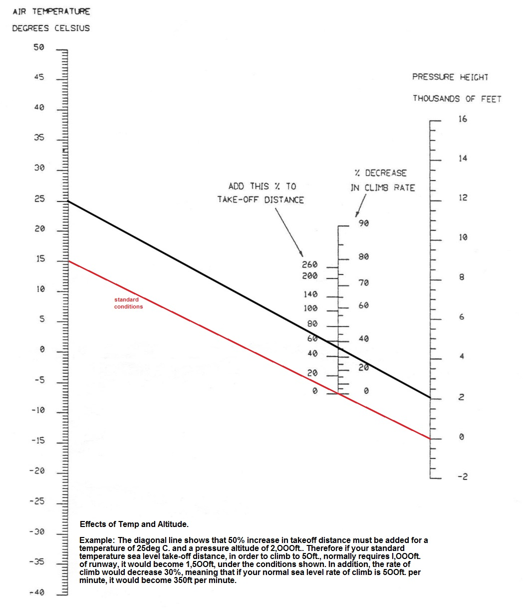

SECTION 6

MAINTENANCE SCHEDULE

6.01 – 25 Hourly Inspection

- Change Oil.
- Change Oil Filter
- Service Air Filter as per manufacturer’s instructions
- Check colour and condition of Spark Plugs
- Check security and condition of Ignition Coil and Leads
- Check Coolant Level
- Check and clean Radiator
- Check Battery and Electrical Cables
- Check Exhaust System for cracks
- Inspect Gimble Head and Main Ring Gear for excessive wear.
- Check electric prerotator - secure
- Remove, clean re-grease and reassemble Rotor Teeter Tower Flange Inserts
- Check Teeter Bolt for fretting or unusual wear
- Check bolts holding Ring Gear to Ring Gear Plate for security
- Check all Rod Ends for side and end-play
- Check Tyres for damage and correct pressure.
- Inspect hub bar & rotor blades – damage, nicks or dings
- Check redrive free play & oil leaks
- Check Trim and Rotor Brake Cables.
- Drain & renew redrive oil

6.02 – 50 Hourly Inspection

- Complete 25 Hourly Inspection
- Check Propeller for security and condition, and re-torque blots
- Check Engine Mounts for cracks and Rod Ends for play
- Check Rudder Cables and Horns for excessive wear
- Check Nose Wheel Steering free
- Check Nose Wheel Shaft for End Play
- Check Rudder Pedals for freedom of movement and lubricate Pivot Points
- Check Wheel Bearings for smoothness and End Play.
- Check rear brake discs for warping or damage
- Check Rudder for cracks around hinge points
- Check main Control Tube Front and Rear “L” Bracket Pivot Points for excessive play
- Check main undercarriage locating blocks.
- Grease front wheel downtube, check spring for sag.
- Inspect undercarriage top rubber suspension.

6.03 – 100 Hourly Inspection

- Complete 25 Hourly Inspection
- Complete 50 Hourly Inspection
- Check Hub Bar for cracks using a 10X magnifying glass
- Lubricate the Teetering Bearing
- Check Radiator Mounts for chafing and leaks
- Check Compression of each cylinder
- Check all cables for wear
- Check Undercarriage Cross Tube (axle) for bow or bending, and check all Rod Ends for excessive play
- Check Undercarriage Support Brackets for cracks or distortion
- Change Fuel Filter
- Remove rocker covers & adjust tappet clearance

6.04 – 200 Hourly Inspection

- Complete 25 Hourly Inspection
- Complete 50 Hourly Inspection
- Complete 100 Hourly Inspection
- Replace Gimble Head Bearing
- Check Reduction Drive Upper Bearings for play and smoothness
- Re-lubricate Torque Tube and Lateral Movement Block with anti-seize compound
- Remove Alternator and inspect Brushes and Bearings
- Replace all Male Rod Ends in Control System.
- Remove throttle body, clean & inspect.

6.05 – 500 Hourly Inspection

- Complete 25 Hourly Inspection
- Complete 50 Hourly Inspection
- Complete 100 Hourly Inspection
- Replace all Fuel Hoses
- Replace Coolant Hoses and Coolant
- Check Throttle Shaft for excessive wear
- Replace bearings in main control system.
- Replace disc brake pads.

